PGSN INTERNSHIP PROGRAM
Technical Report
Week 3 Extension
Advanced AWS Compute & Networking | Infrastructure as Code, CI/CD & Containerization
Prepared by: Sai Venkat

Week 3 Extension: Infrastructure as Code, CI/CD & Containerization
This module covers provisioning AWS infrastructure using Terraform, applying Infrastructure as Code (IaC) best practices, building CI/CD pipelines with GitHub Actions, containerizing applications using Docker, and automating deployment to AWS.

Learning Objectives
- Provision AWS infrastructure using Terraform.
- Understand Infrastructure as Code (IaC) best practices.
- Build CI/CD pipelines using GitHub Actions.
- Containerize applications using Docker.
- Deploy applications to AWS automatically.
- Implement infrastructure versioning and state management.

Day 1 – Terraform Fundamentals

Topics Covered
- Infrastructure as Code (IaC)
- Terraform Architecture
- Providers
- Resources
- Variables
- Outputs
- Terraform State

Implementation Tasks
- Install Terraform.
- Configure AWS Provider.
- Create an S3 bucket using Terraform.
- Create an EC2 instance using Terraform.
- Use variables instead of hardcoded values.
- Output the EC2 Public IP.
- Destroy all resources using Terraform.

Evidence and Screenshots
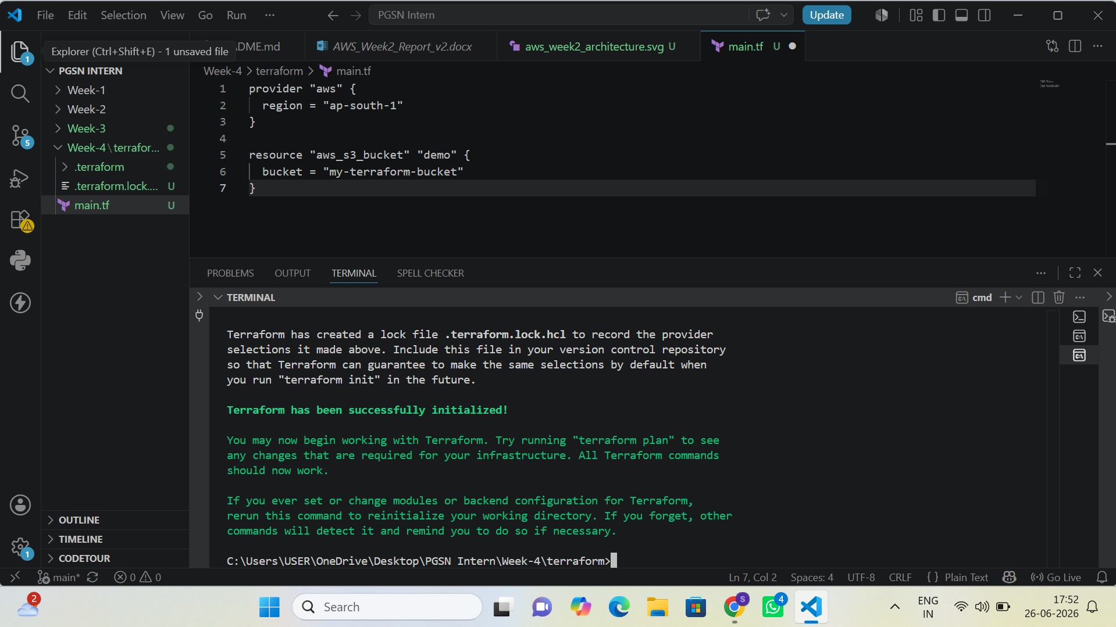
Figure 1: Terraform Initialization (terraform init) in VS Code
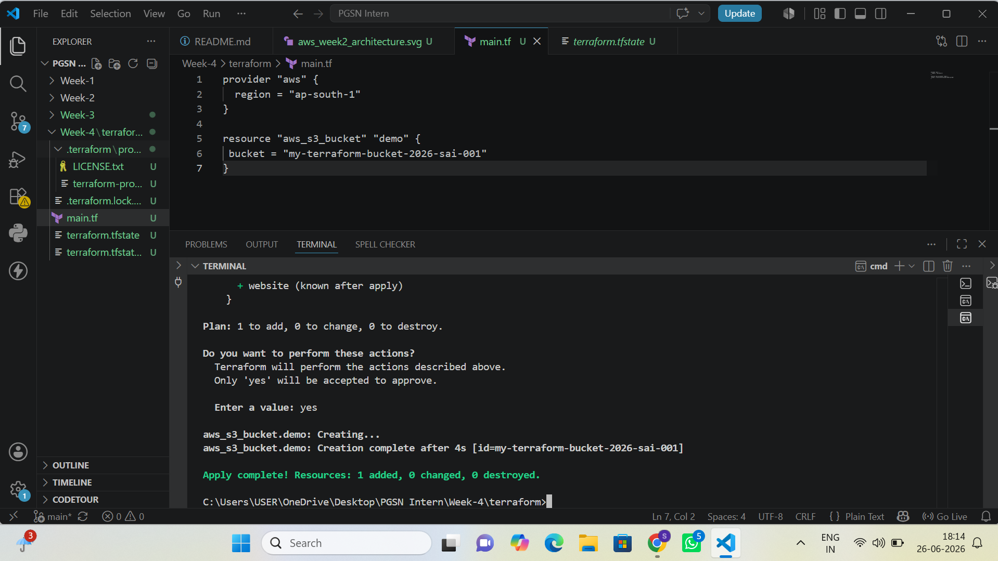
Figure 2: Terraform Apply – S3 Bucket Resource Creation Confirmed
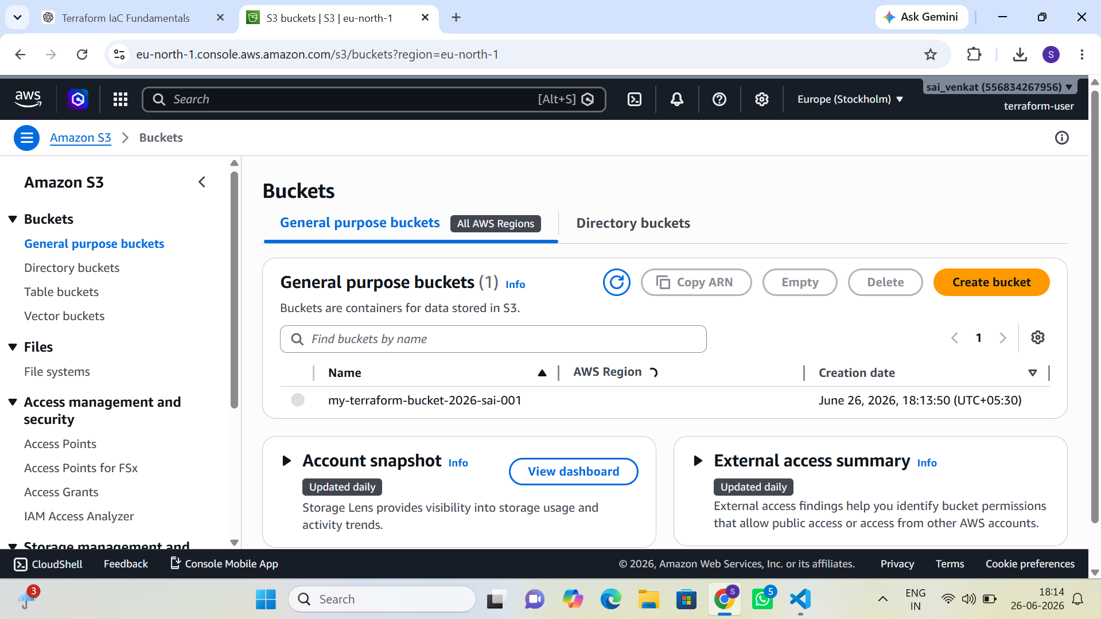
Figure 3: AWS S3 Console – Bucket Created via Terraform
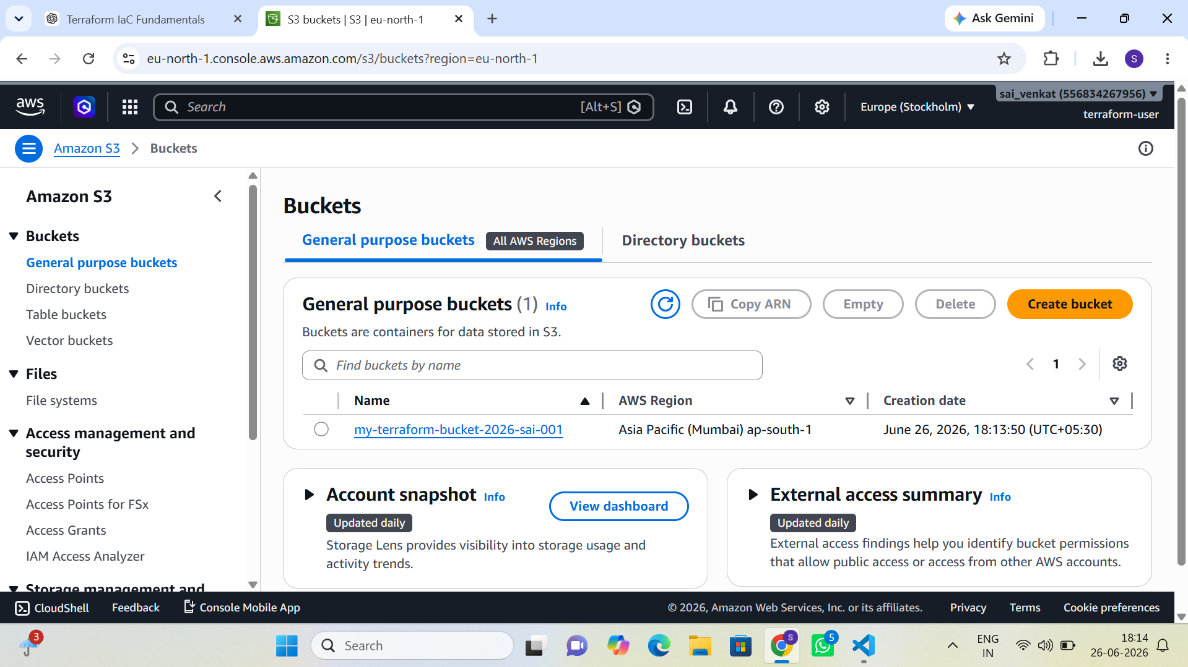
Figure 4: AWS S3 Console – Bucket Region and Creation Date Verified
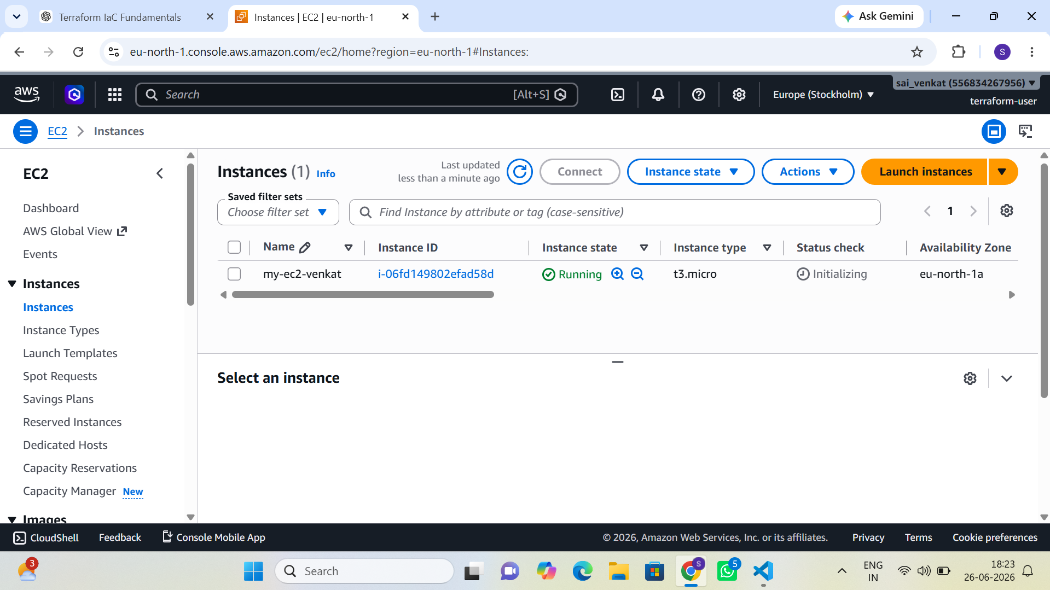
Figure 5: AWS EC2 Console – Instance Launched and Running

Day 2 – Modular Infrastructure

Topics Covered
- Terraform Modules
- Remote State
- Backend Configuration
- Terraform Workspaces

Implementation Tasks
- Create reusable VPC Module.
- Create EC2 Module.
- Create Security Group Module.
- Store Terraform state in an S3 backend.
- Create separate Dev and Prod workspaces.
- Deploy infrastructure using modules.

Evidence and Screenshots
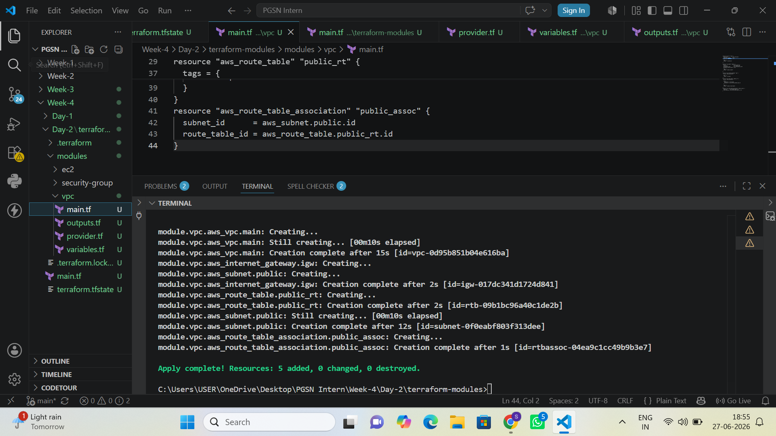
Figure 6: VPC Module Apply – Subnet, Route Table, and Gateway Resources Created
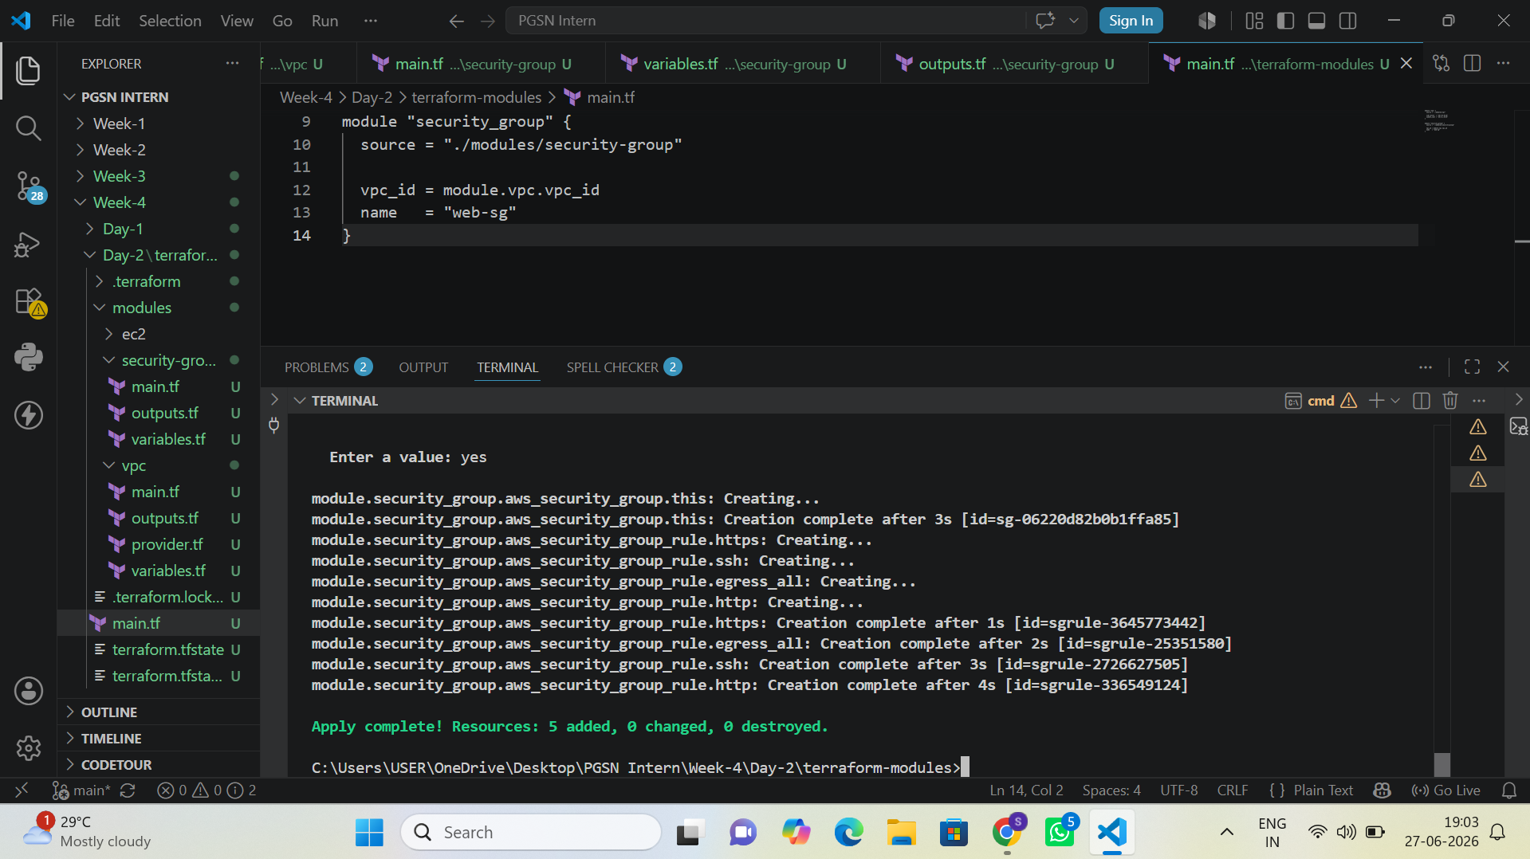
Figure 7: Security Group Module Apply – Inbound and Outbound Rules Created
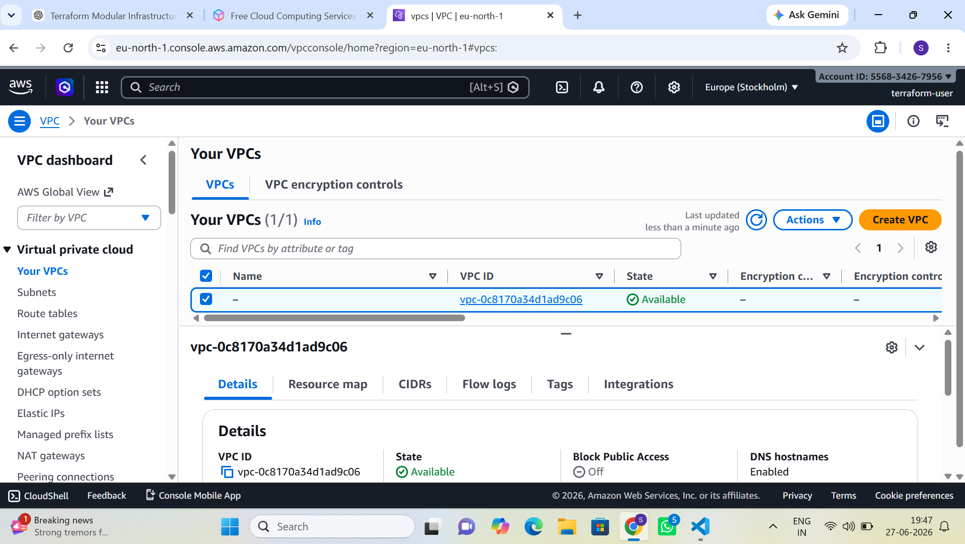
Figure 8: AWS VPC Console – VPC Provisioned via Terraform Module
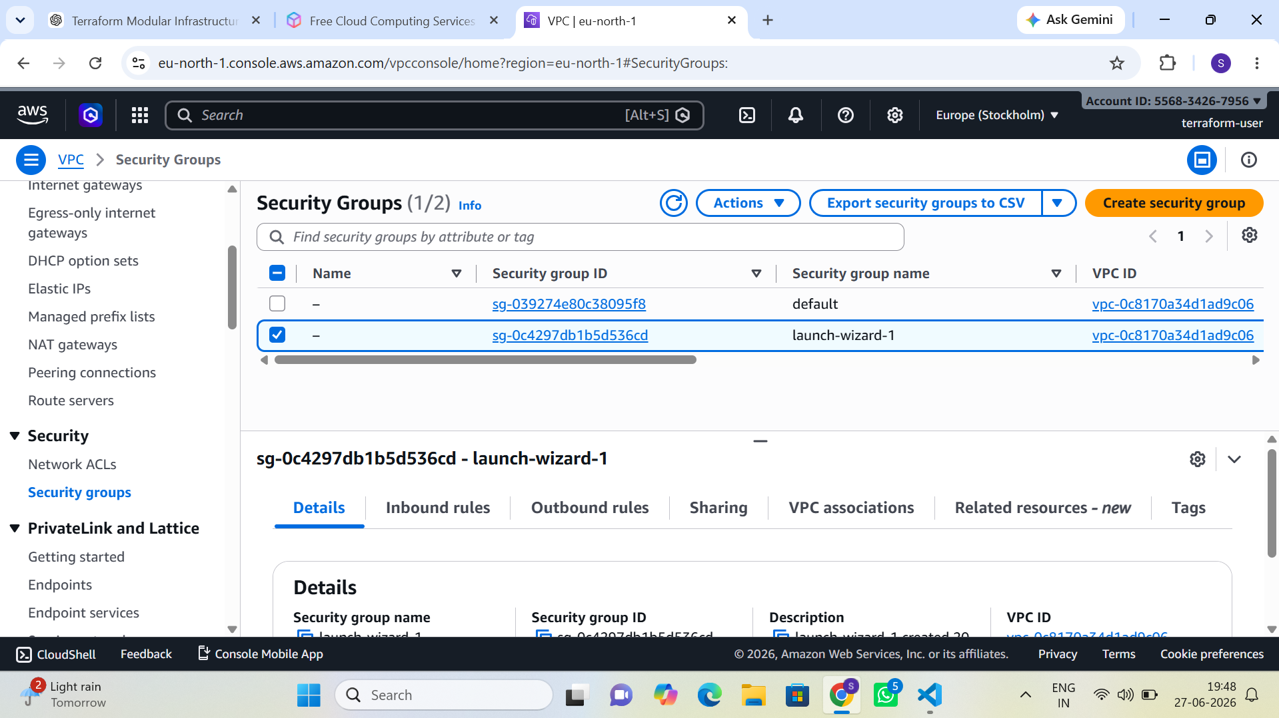
Figure 9: AWS VPC Console – Security Groups Created via Terraform Module

Day 3 – Docker Fundamentals

Topics Covered
- Docker Architecture
- Docker Images
- Containers
- Dockerfile
- Docker Volumes
- Docker Networking

Implementation Tasks
- Install Docker.
- Create a Dockerfile for a sample web application.
- Build a Docker image.
- Run the container locally.
- Mount persistent volumes.
- Push the Docker image to Docker Hub.

Evidence and Screenshots
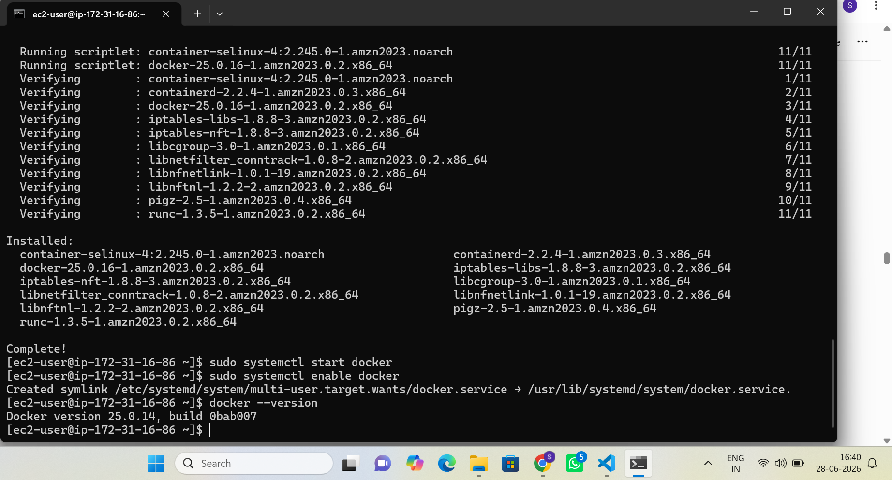
Figure 10: Docker Engine Installation on EC2 (Amazon Linux 2023)
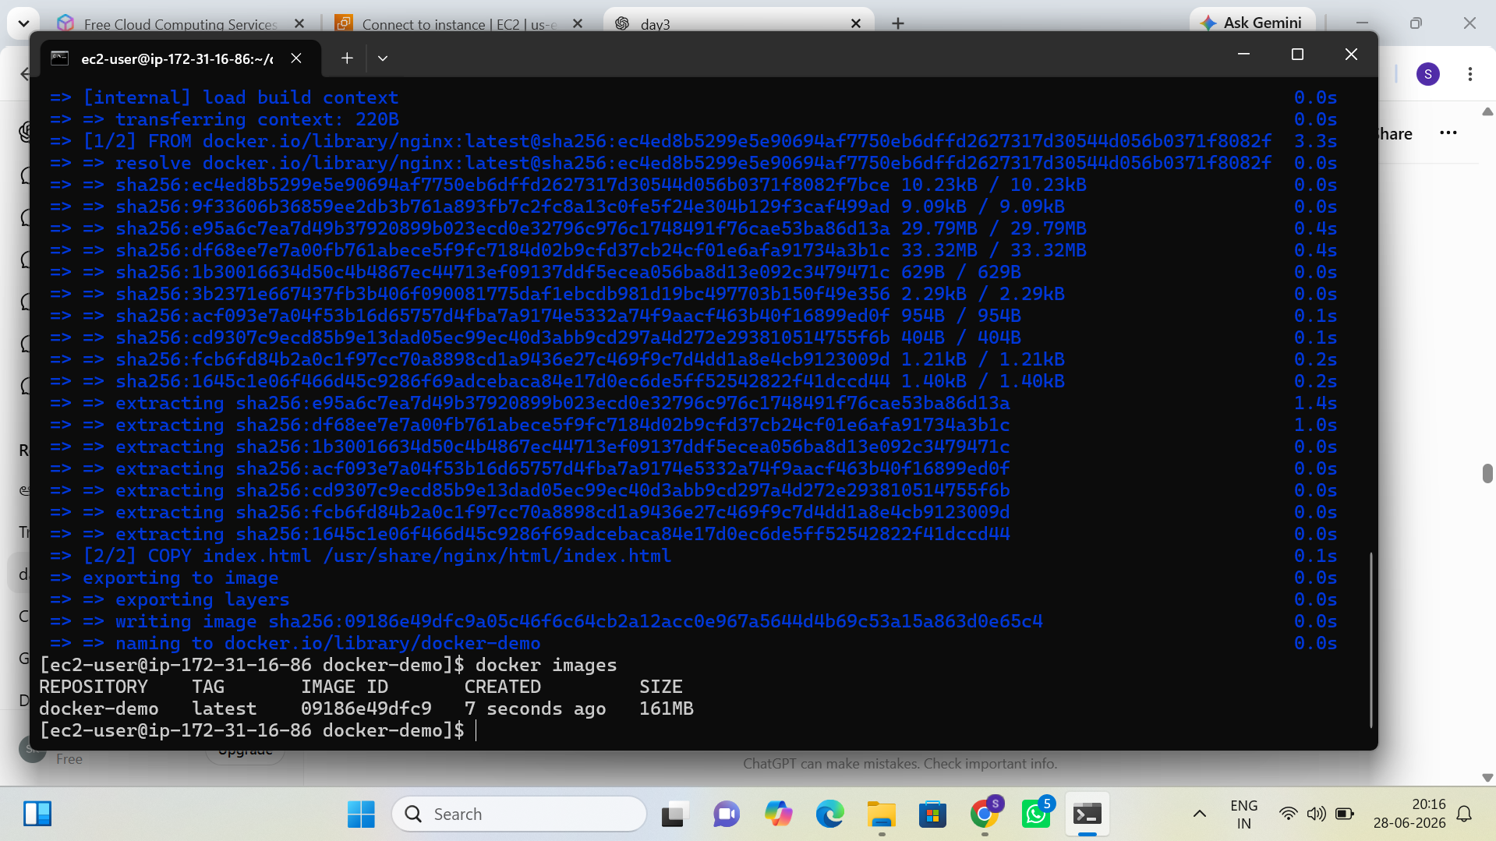
Figure 11: Docker Image Build – Nginx-based docker-demo Image
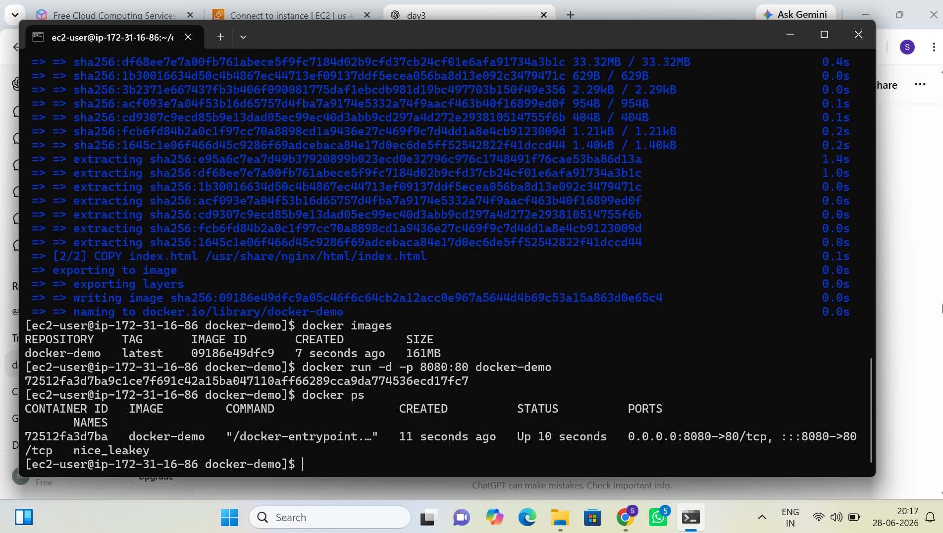
Figure 12: Docker Container Running – Port Mapping Verified (docker ps)
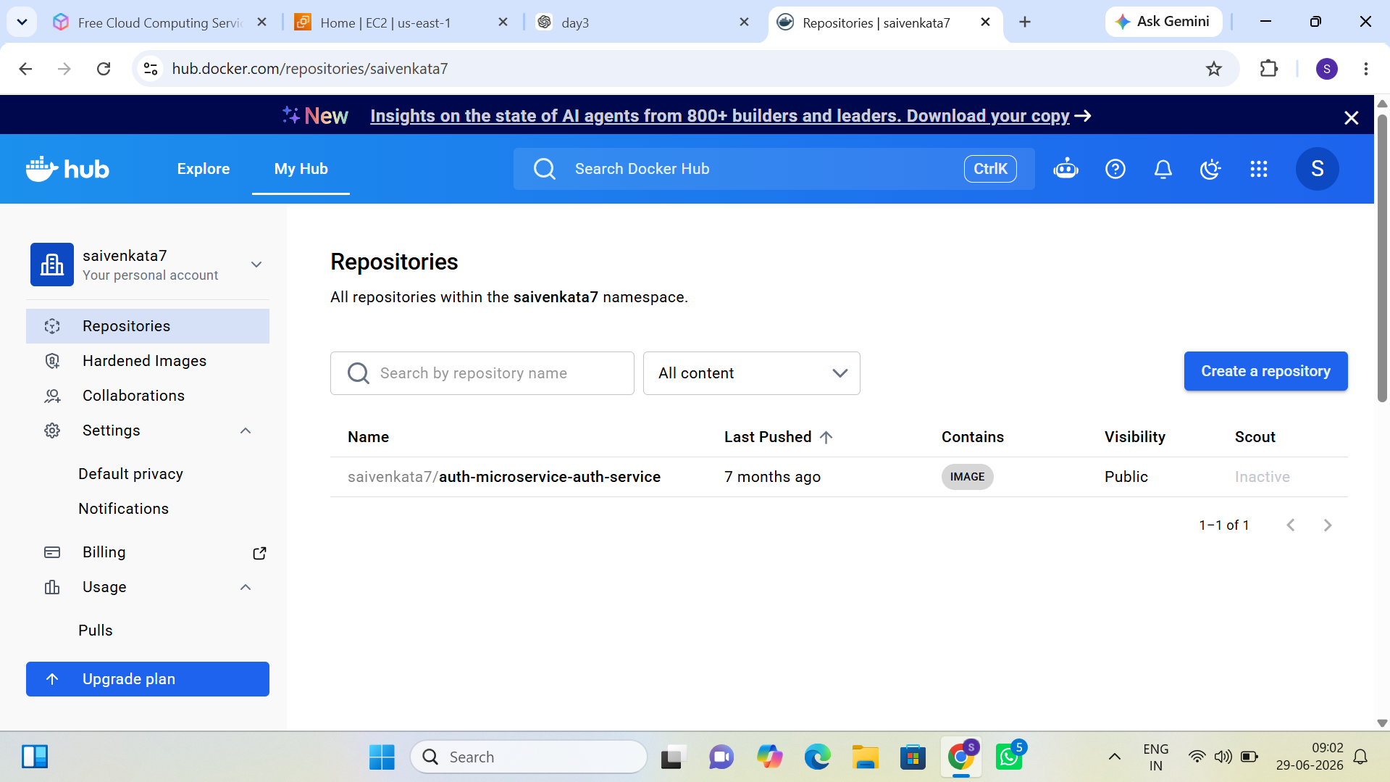
Figure 13: Docker Hub Repository – Image Pushed Successfully

Day 4 – CI/CD with GitHub Actions

Topics Covered
- Continuous Integration
- Continuous Deployment
- GitHub Actions
- Workflow Files
- Secrets Management

Implementation Tasks
- Create a GitHub repository.
- Configure GitHub Actions.
- Automatically build the application on every push.
- Run unit tests.
- Build Docker image.
- Push Docker image to Docker Hub.

Evidence and Screenshots
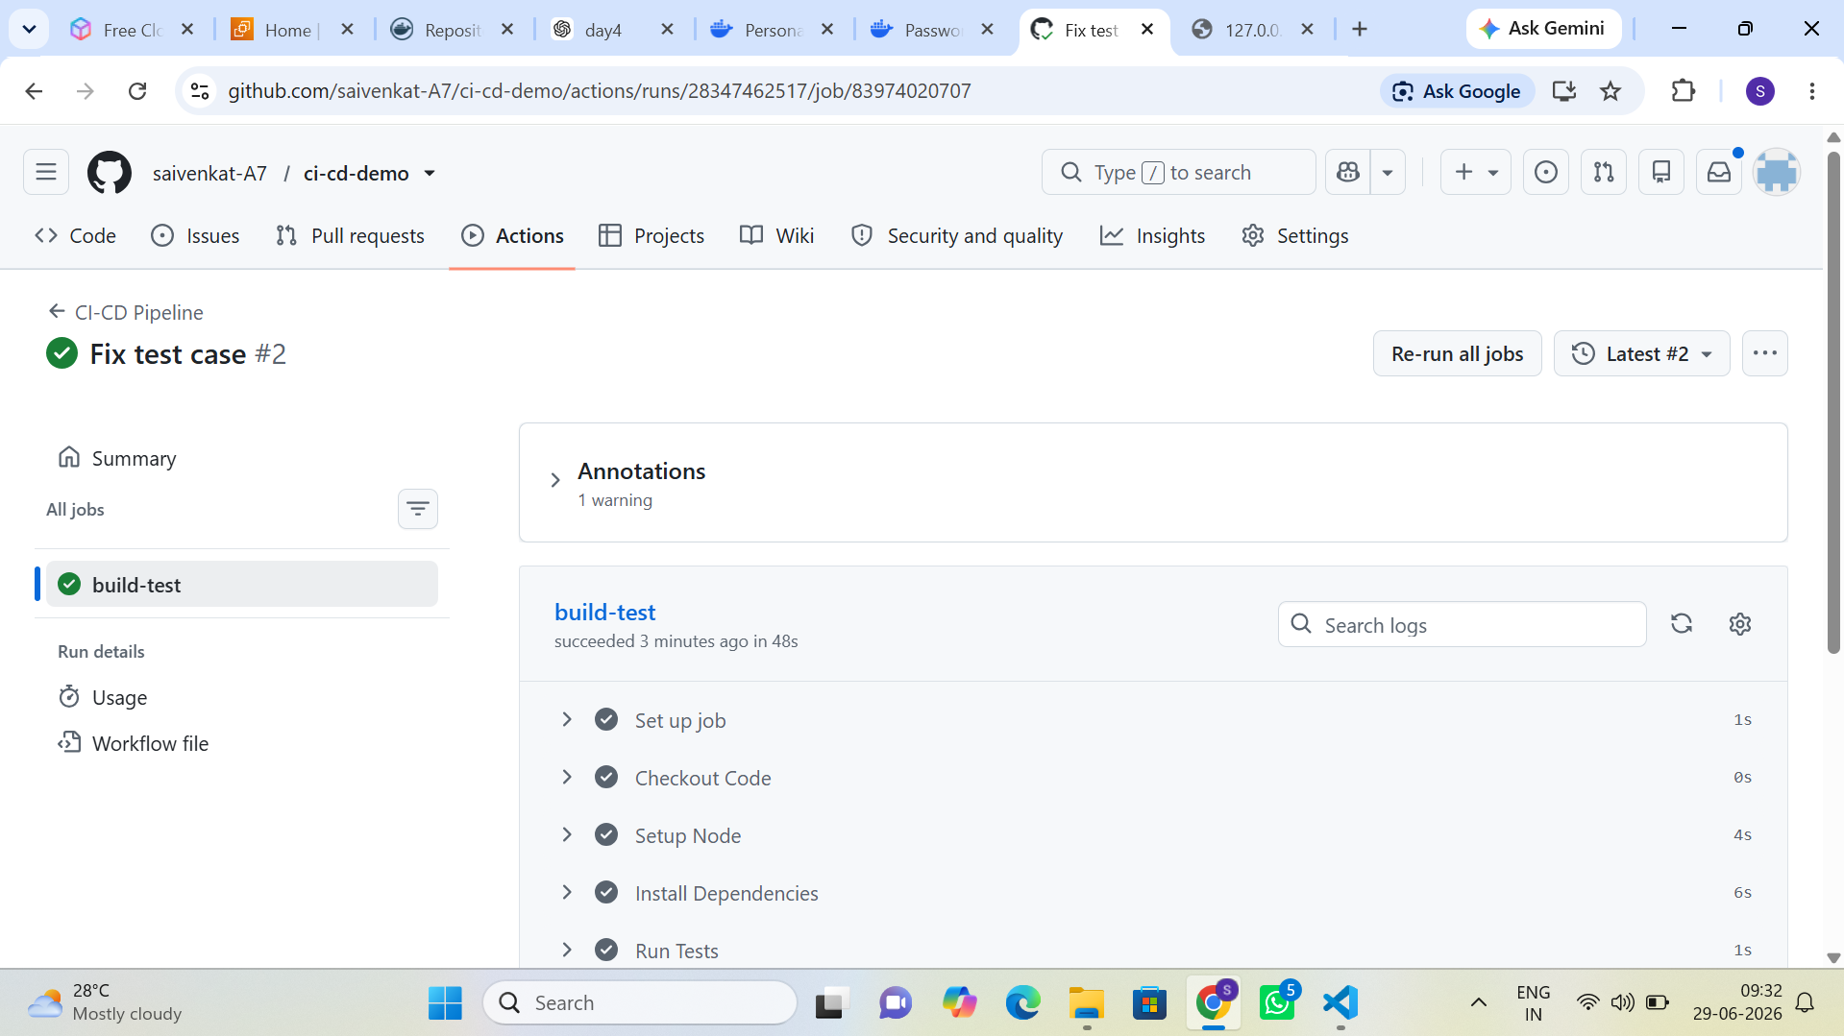
Figure 14: GitHub Actions Workflow – build-test Job Succeeded
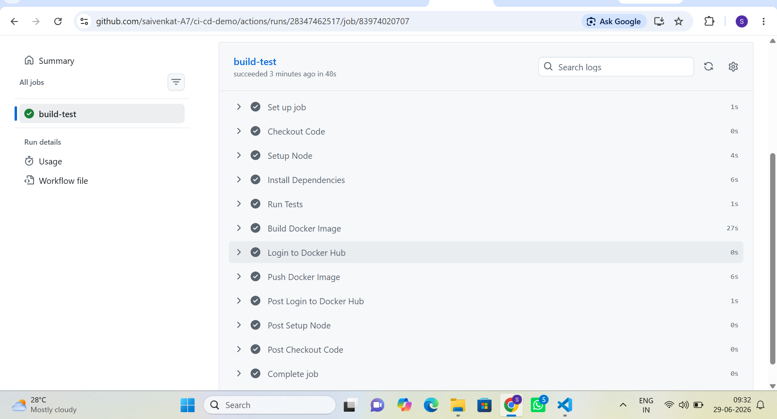
Figure 15: GitHub Actions – Build and Push Docker Image Steps Completed
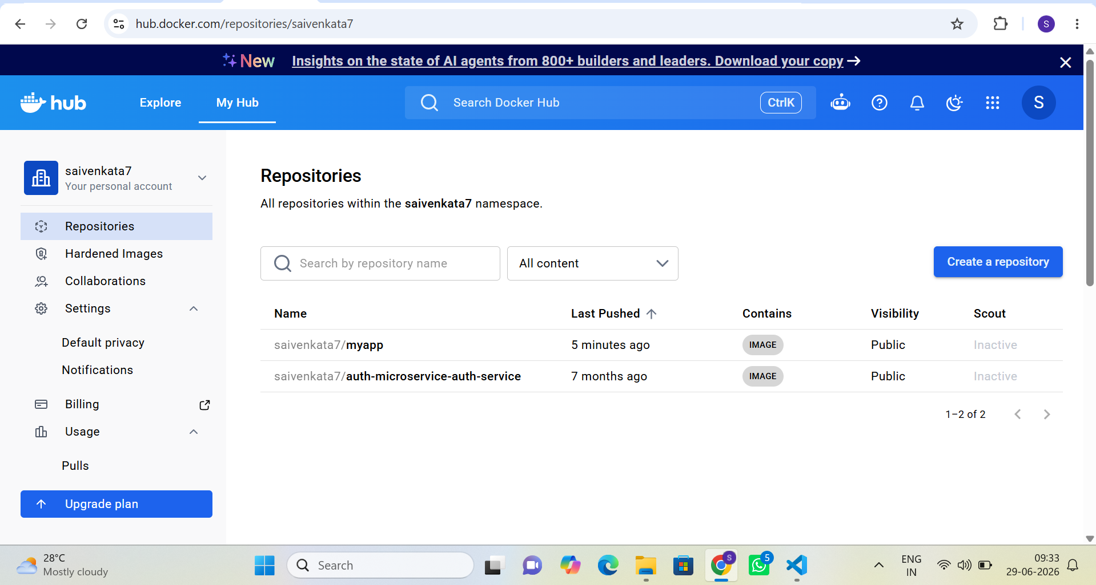
Figure 16: Docker Hub Repositories – myapp Image Pushed via CI/CD Pipeline
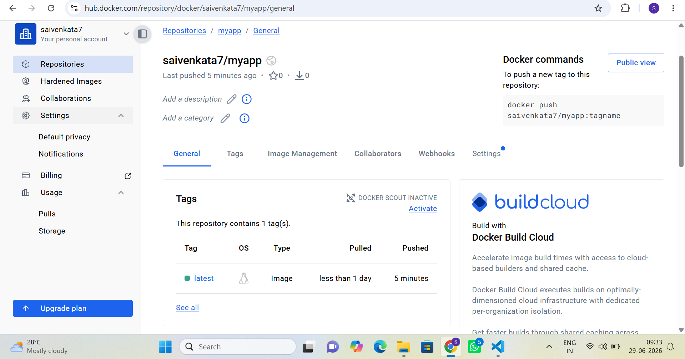
Figure 17: Docker Hub – myapp Repository General Page and Tag Details

Day 5 – AWS Deployment Automation

Topics Covered
- Code Deployment Strategies
- Environment Variables
- Deployment Automation

Implementation Tasks
- Launch EC2 using Terraform.
- Install Docker automatically using User Data.
- Pull Docker image from Docker Hub.
- Run the application container.
- Verify application accessibility.

Evidence and Screenshots
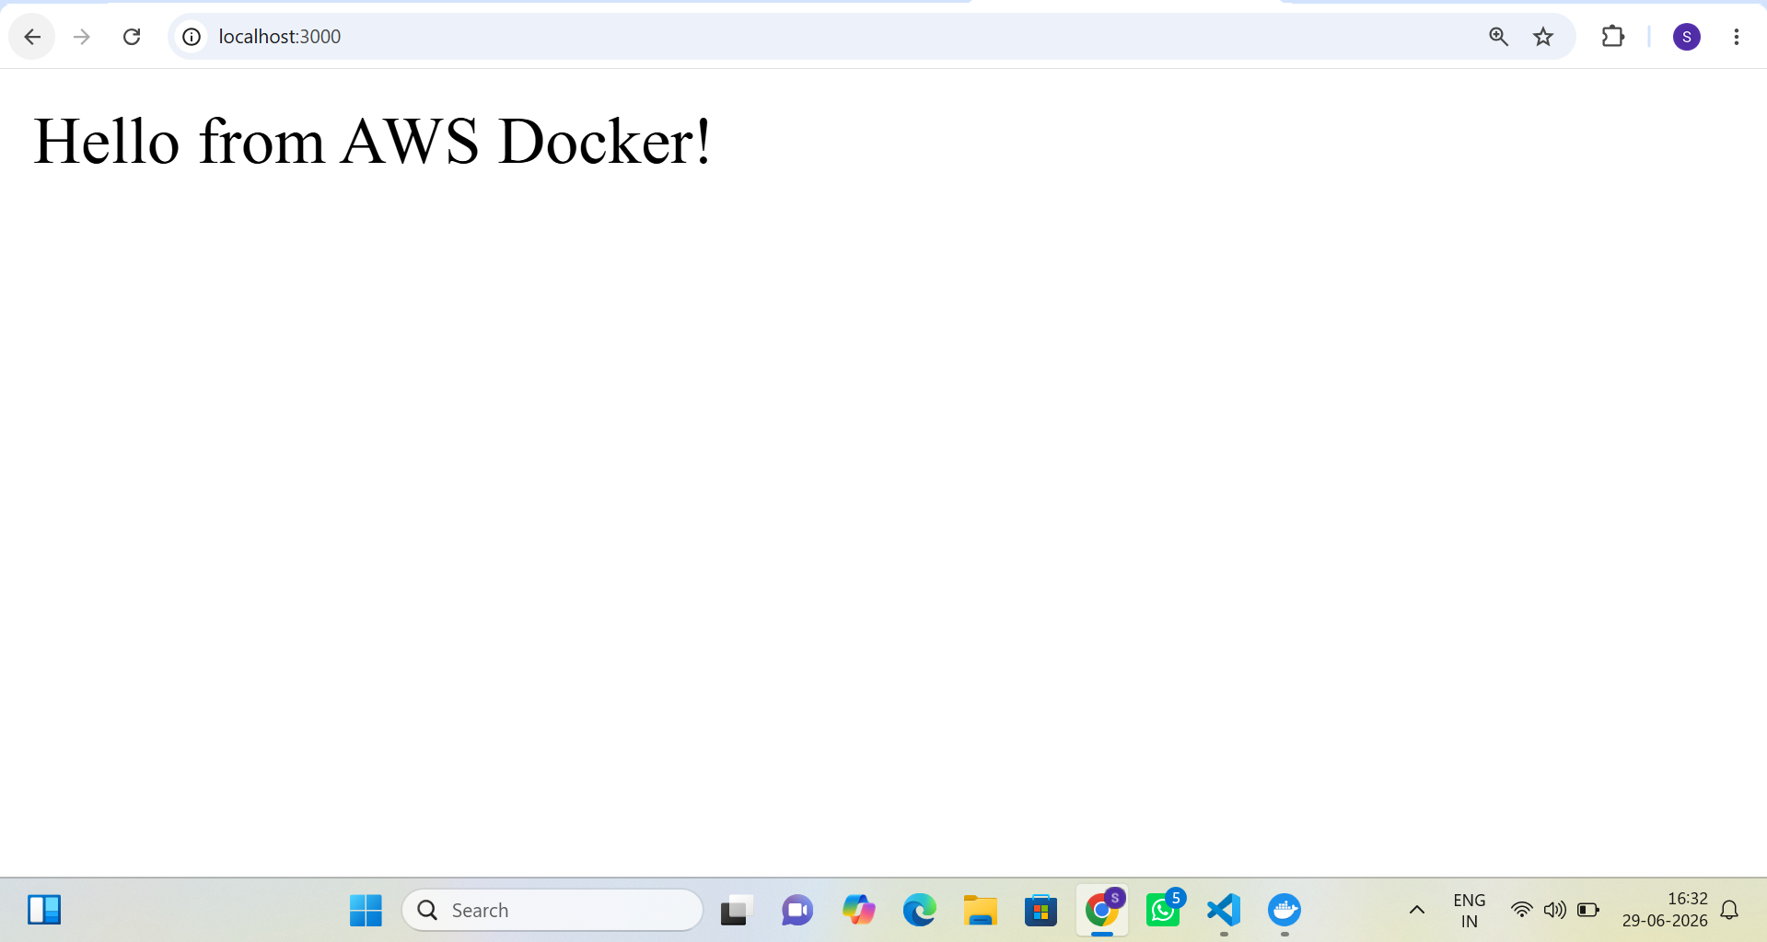
Figure 18: Application Verified in Browser – “Hello from AWS Docker!” Response
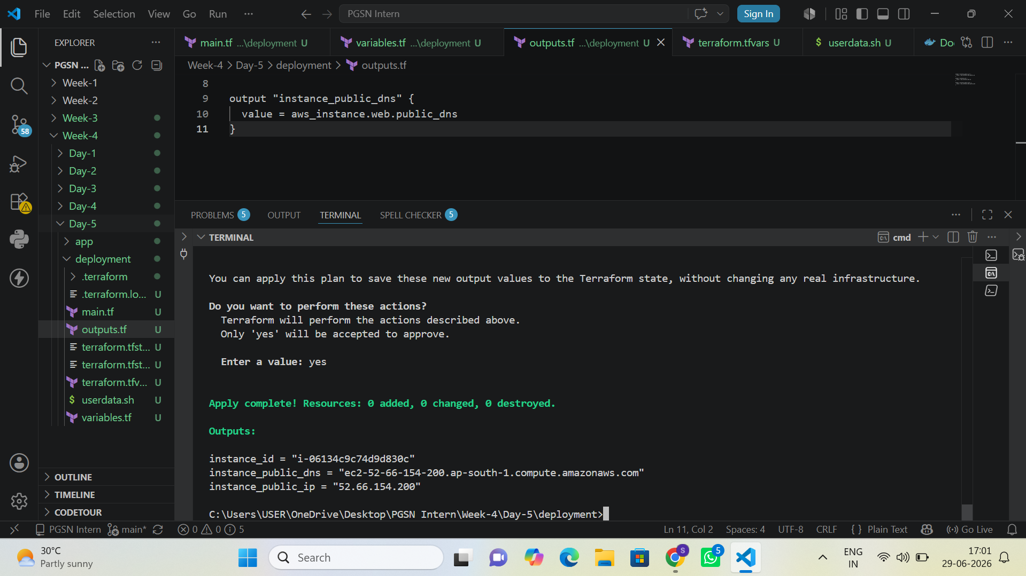
Figure 19: Terraform Apply Output – EC2 Instance ID, Public DNS, and Public IP

Day 6 – Monitoring & Logging

Topics Covered
- Docker Logs
- CloudWatch Logs
- CloudWatch Alarms
- Application Monitoring

Implementation Tasks
- Configure CloudWatch Agent.
- Send application logs to CloudWatch.
- Create CPU utilization alarms.
- Create disk usage alarms.
- Verify alarm notifications.

Evidence and Screenshots
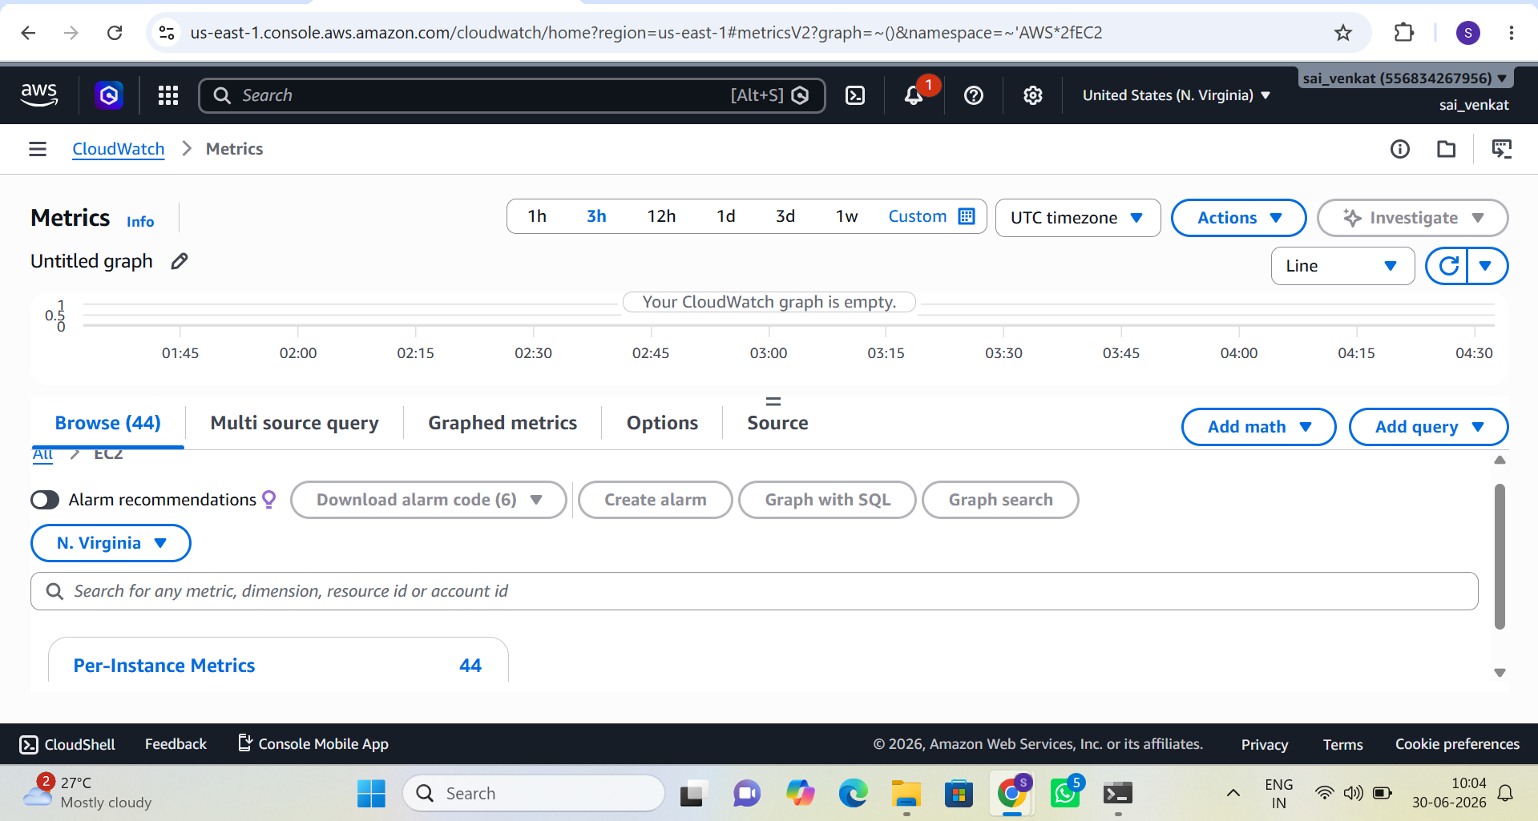
Figure 20: AWS CloudWatch Metrics Console – EC2 Namespace Initialized
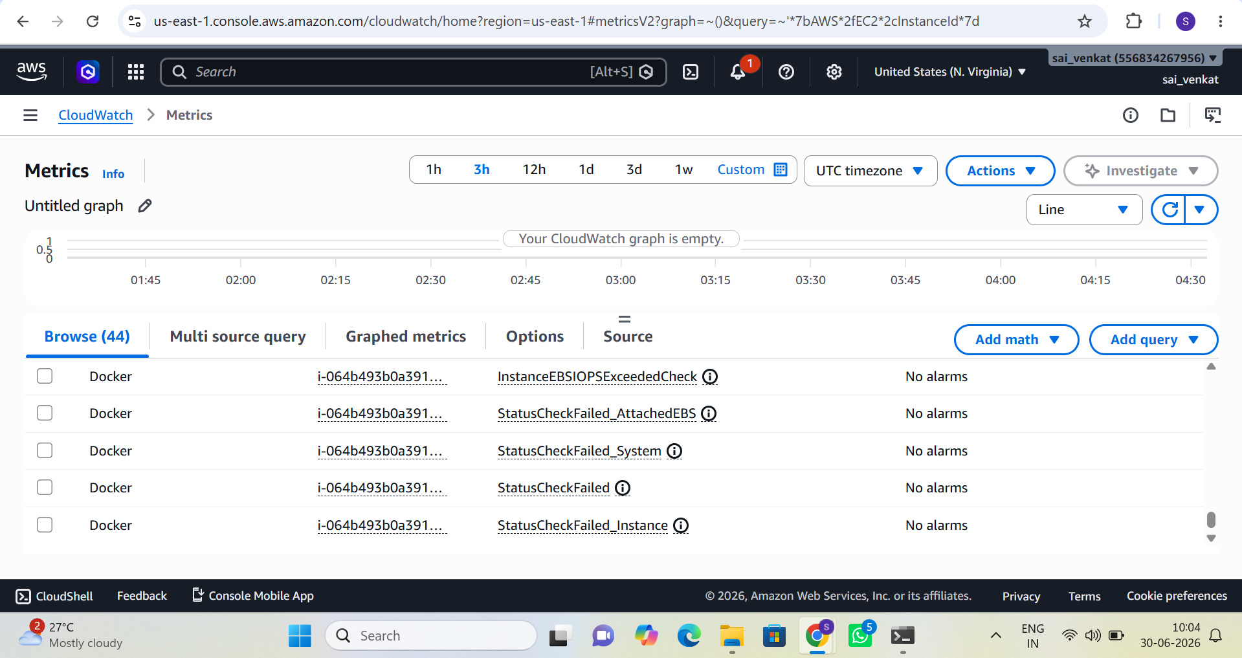
Figure 21: AWS CloudWatch – Per-Instance Status Check Metrics for Docker EC2 Instance

Day 7 – Final Project

Project Scope
Deploy a complete production-ready web application using Terraform, AWS VPC, EC2, Security Groups, IAM Roles, an S3 Backend, Docker, GitHub Actions, and CloudWatch.

Deliverables
- GitHub Repository
- Terraform Code
- Dockerfile
- GitHub Actions Workflow
- Architecture Diagram
- Deployment Guide
- README
- Screenshots of deployment and monitoring

Bonus Objectives
- Use Terraform Modules.
- Use Remote Backend.
- Configure HTTPS with Nginx reverse proxy.
- Implement Zero Downtime Deployment.
- Configure Auto Deployment on every Git push.

